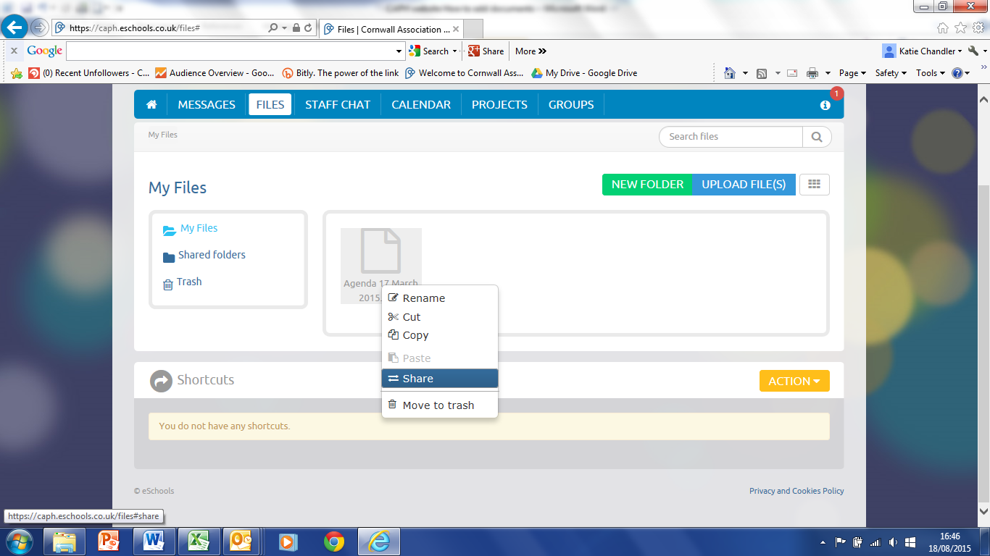**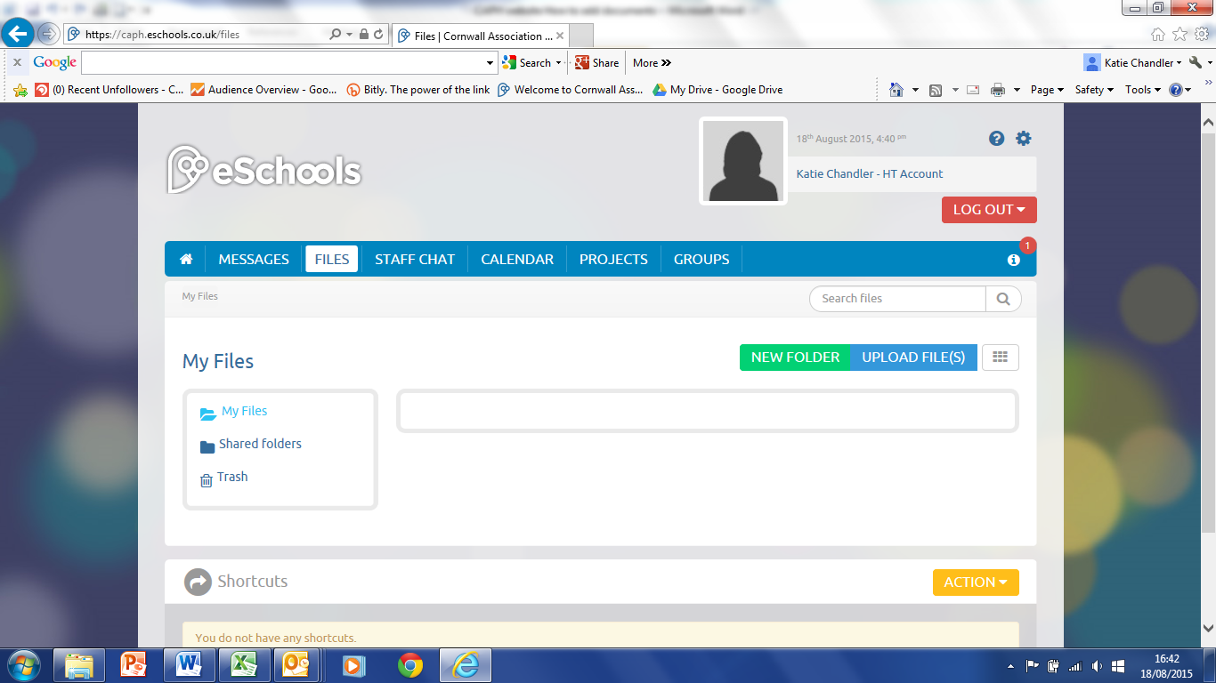How to upload and share documents**

**3. Right click on uploaded file, click on ‘share’**

**2. Click on ‘upload files’**

1. **Click on ‘files’**

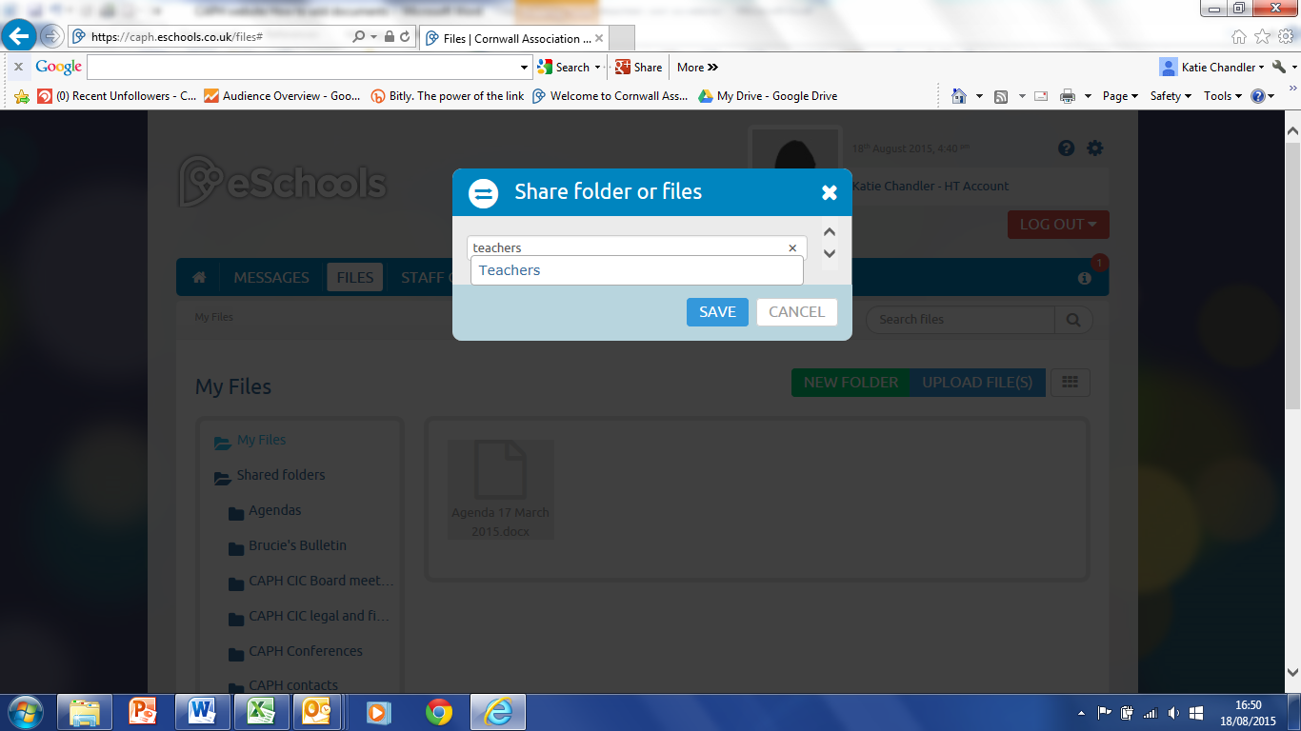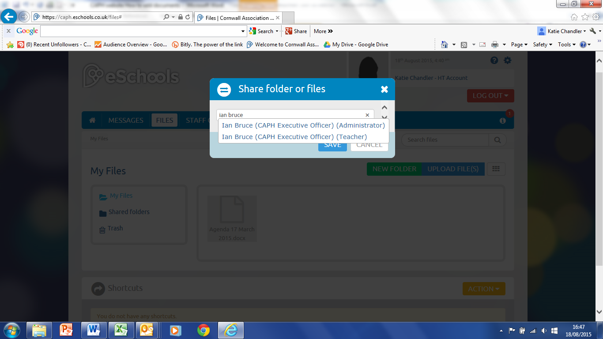

**5. to share with all heads, type teacher and select**

**4. type in name of who you want to share with and select, select view only or edit on next screen**