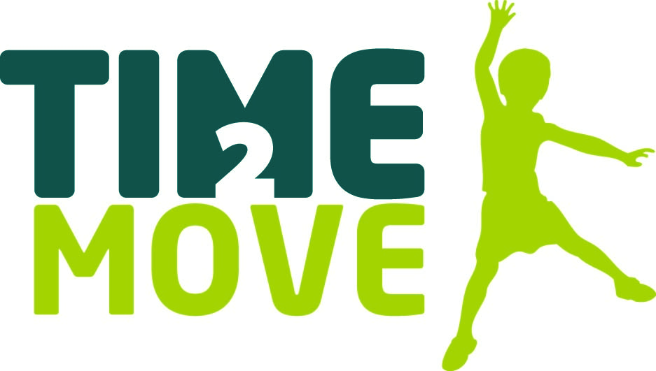

Primary School Award

Introduction
For the second year, CAPH and the Cornwall Sports Partnership have teamed up to celebrate primary schools that are delivering excellent practice in PE and School Sport.
We are seeking nominations from schools with examples of work driving forward the six ambitions of the Time 2 Move Framework:
Ambition 1 – Curriculum delivery
Ambition 2 – Physical activity, health & wellbeing
Ambition 3 – Diverse & inclusive
Ambition 4 – Competitions
Ambition 5 – Leadership, Coaching & Volunteering
Ambition 6 – Community Collaboration
Click here to see 2016 shortlisted schools, and winners Marazion School
Basic Criteria
- The activity should contribute towards achieving one or more of the Time 2 Move ambitions
- The activity must have happened in the academic year 2016/17
- The school must be an affiliated member of CAPH
Application
Please complete the following nomination form and return to: rknott@cornwall.gov.uk or mail to T2M Awards, Cornwall Sports Partnership, E0, New County Hall, Truro, Cornwall TR1 3AY
Timeline
15th September 2017 – Nominations close
22nd September – Shortlisted finalists announced & invited to Cornwall Sports Awards
TBC 3rd or 10th November – Winner announced at Cornwall Sports Awards

Primary School Award
 | School: |  | Lead Contact:
 | Email: |  | Telephone:
Tell us how your school is meeting the T2M ambitions? 250 words
What priority/needs did you identify and which ambitions? What did you set out to achieve? Who did you aim to work with? How did you decide to tackle this? What actions were taken? Who was involved? What did you do? What did it look like?

What difference did this make to the pupils? 250 words
What was the impact on the children’s personal/physical/mental/social development? How did you know/evaluate this? Include a young person quote

What were the wider impacts on the school? 250 words
Which school priorities has it impacted on? How has this changed the way you work with young people? Include a Head Teacher quote

 | What were the key things that made this work? 250 words
What will you do next? 250 words
How are you embedding/sustaining/extending and developing the impact of this work?

