**Cornwall and Isles of Scilly Safeguarding**

**Children Partnership**

The SCP Learning Group

Invites you to attend a

**Learning Lessons Workshop**

**Tuesday 13th June 2017**

**At St Erme Community Centre (Directions below)**

**(Session 1) 9:30am to 12:30pm**

**(Session 2) 13:30pm to 16:30pm** (repeat of session 1)

Tea and coffee available from 9:00am & 13:00pm

**SIGNS OF SAFETY**

Signs of Safety is the core **multiagency** approach to working with families in Cornwall and managing risk where children are in need of help and protection.

In this session you will learn about the Signs of Safety approach, hear from practitioners about the impact of Signs of Safety on their work, and practice some of the core aspects of the model in group discussions.

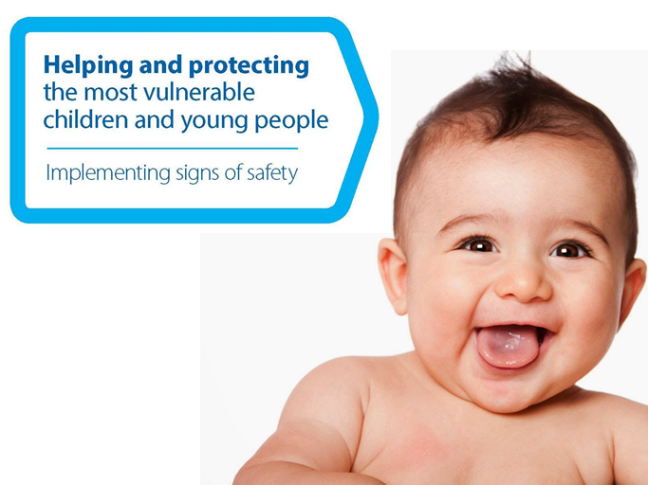

To book, please contact Nathan Oates, Safeguarding Admin Assistant, at [Nathan.Oates@cornwall.gov.uk](mailto:Nathan.Oates@cornwall.gov.uk) stating which session you prefer.

(Please be aware that if less than 20 people book for the workshop it will be cancelled as it will not be viable).

Information presented at the workshops will be available to download from the SCP website –[**www.safechildren-cios.co.uk**](http://www.safechildren-cios.co.uk)after the events.

# How to Find St Erme Community Centre

**By Car**

St Erme Community Centre is located 4 miles north of the city of Truro and 2 miles from the A30. There is ample parking on site for 70 cars.

From the A30 continue towards Truro for approx 2 miles turn left in to Trispen at 'Rowes Honda' then immediately left and immediately right into 'Castle Field’.

From Truro take the A39 towards Bodmin after approx 4 miles you will reach the parish of St Erme take the second turning right into Trispen at 'Rowes Honda' then immediately left and immediately right into 'Castle Field'.

**By Bus**

The main bus station is in Truro and there is a half hourly bus service to St Erme. The bus stop is 250m from the facility.   
