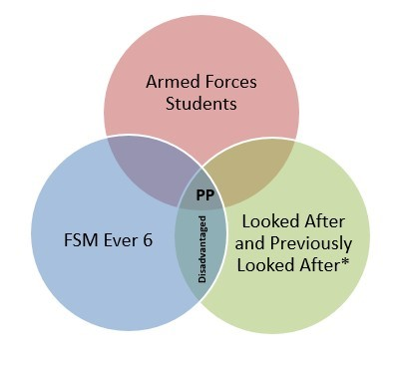

**Strategies**

* Staff member overseeing Pupil Premium –
* Regular updates –
* Understanding individual pupils –
* High Quality Teaching -
* Targeted Academic support –
* Regular check in with target families –
* Attendance –

**School context**

**Staff**

* Data -
* Inset training -
* Support –
* Monitoring –
  + Work scrutiny
  + Learning walks

**Know our pupils**

**Pupil**

**Premium**

**Cultural Capital**

**Breakdown of Pupil Premium**

* Wholeschool -
* EYFS -
* KS1 -
* KS2 -
* Male / Female -
* Children in care -
* Service Children -
* SEND / EHCP -
* EAL -



**Attendance**

* Trends –
* Identify key pupils and barriers –
* Supporting attendance –
* First day calls –
* Remove potential financial barriers to attendance -
* Delivering short term support for students to remove barriers of attendance to school and to lessons –

**Spending**:

* Overall -
  + Staffing/CPD -
  + Targeted Academic support
  + Wider strategies

**Resource Provision**

**Communication**

* Parents –
* Pupils –
* Staff –
* Governors

**Tracking**

* Governors –
* Data collection -
* Sharing information –
* Attendance/behaviour/progress -
* Intervention and tutoring –
* Cultural capital -

**Opportunities**

**Strengths**

1. Whole school focus –
2. Understanding individual pupils –



1. Behaviour and safeguarding
2. Consistency –
3. Communication with all stakeholders -
4. Parental support.
5. Community.
6. Responding to staff voice – PPA, Curriculum, behaviour

**Wellbeing / behaviour**

* Policy –
* Support –
* Data analysis –
* Mental health and pastoral support –

**Intervention**

Planned interventions for individuals and small groups.

Effectiveness / impact:

Tracking and monitoring:

Cost benefit:

Interventions include:

**Data information**

* Trends –
* Communication -
* Key info –
* Support staff -
* Rewards/Sanctions -
* Key issues -

**Data**