Cornwall Prevent Update - September 2026
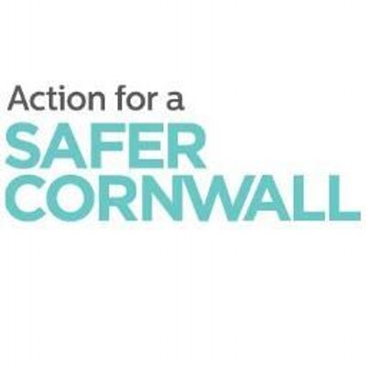

Cornwall education Partnership Safeguarding and CP Network
The purpose of this 5 point - 5 minute briefing is to highlight the current Prevent landscape, key concerns for education settings, and what DSLs should be particularly alert to this academic year.
The UK terrorist threat level remains SEVERE, meaning an attack is considered highly likely. Prevent continues to be a key part of the Government's CONTEST strategy and focuses on safeguarding individuals who may be susceptible to radicalisation before they become involved in terrorism.
Recent Home Office data shows a significant increase in Prevent referrals, with education continuing to be the largest referring sector. Young people aged 11 to 15 remain the most frequently referred age group.

Key Emerging Concerns for Schools

1. Online Radicalisation
The most significant threat facing young people continues to be online radicalisation.
Young people are increasingly exposed to:
- Extremist content on social media platforms
- Conspiracy theories
- Misinformation and disinformation
- Violent content and school-shooter narratives
- Self-radicalisation through online forums and gaming platforms
- Information on forums outside of the Western Hemisphere where online controls and security are lacking
Many cases no longer involve membership of a recognised extremist group. Instead, individuals may consume a mixture of harmful online content leading to fascination with violence, grievance narratives, or extremist worldviews.

2. Ideologically Uncertain Cases
A growing number of Prevent in Cornwall are now categorised as having no clear ideology.
These individuals may demonstrate:
- Obsession with mass casualty attacks
- Fixation on violence
- Interest in previous terrorist incidents
- Mixed extremist influences from multiple sources
Professionals should focus on behaviours and vulnerabilities rather than trying to identify a specific ideology.

3. Extreme Right-Wing Activity
Extreme right-wing concerns continue to represent a significant proportion of referrals and currently exceed Islamist-related referrals in Prevent statistics.
Indicators may include:
- Racist, anti-Semitic or anti-Muslim narratives
- Promotion of white supremacy
- Use of extremist memes and symbols
- Admiration of perpetrators of terrorist attacks
These views are often encountered initially through online communities, gaming forums or social media.

4. Vulnerability and Mental Health
Cases increasingly involve complex safeguarding vulnerabilities including:
- Social isolation
- Neurodiversity
- Mental health concerns
- Trauma
- Bullying
- Family instability
It is important to remember that mental health or neurodiversity do not cause extremism. However, vulnerabilities may increase susceptibility to manipulation by those seeking to radicalise young people.

What DSLs Should Do

Ensure that staff in your respective setting are alert to
Changes in:
- Behaviour
- Friendship groups
- Online activity
- Language used
- Fixations on violence
- Expressions of hatred or intolerance
- Attempts to justify violence

Strengthen Protective Factors
Ensure your setting:
- Promotes critical thinking
- Develops media literacy
- Encourages respectful debate
- Supports inclusion and belonging
- Delivers effective online safety education
- Embeds Fundamental British Values appropriately

Use Existing Safeguarding Pathways
If concerned:
- Record concerns.
- Discuss with the DSL.
- Seek advice from HQ Prevent Team where appropriate. Always ring the team prior to referral submission. (See below)
- Remember Notice, Check Share and embed this across your respective settings.

