

**OU/ UKLA Teachers Reading Group**

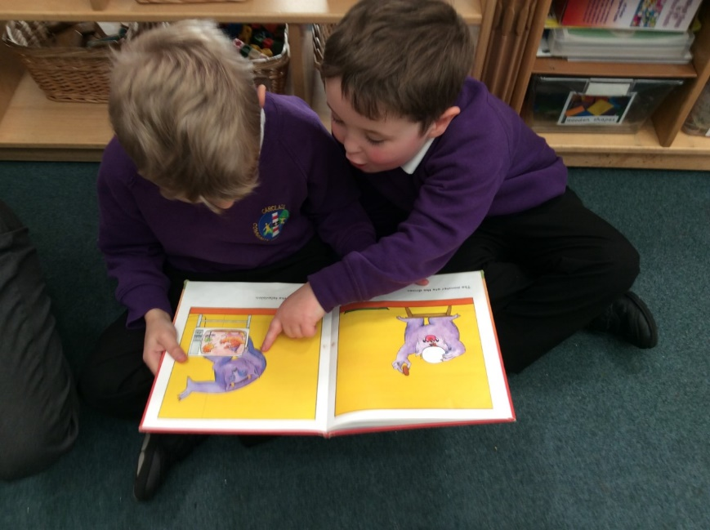

**Do you want to develop children’s pleasure in reading?**

**Then join us to enrich your knowledge and practice!**

**Carclaze School** invites anyone committed to developing young people’s desire, delight and engagement as readers to join our **in person** OU/UKLA Reading Group. Informal, friendly and supportive we welcome teachers, librarians, student teachers and support staff to join us and commit to attending all five CPD sessions after the launch.

We will be developing evidence-informed practice, widening our knowledge of stunning literature and other texts written for children, enriching our RfP pedagogy and documenting the impact on the young people as readers.

**When: Launch: September 15th (3.30 – 4.30)**

**Then: Thursday’s October 6th, December 1st,** **January 12th, March 9th and April 27th**

**Time**: All 3.30-5.30

**Come along to the launch to find out more…**

**To book a place email: spollard@carclazesch.org or ring: 01726 74194**

