INVITATION TO ATTEND
Safeguarding Learning Together Week
Bearing Witness to Child Sexual Abuse and
Child Sexual Exploitation
27 June 2022 – 1 July 2022
12noon to 1pm each day
NHS Safeguarding are pleased to invite you to the following events to be inspired and bear witness to effect change.
This year we have 7 fabulous speakers who will be presenting on Child Sexual Abuse and Child Sexual Exploitation.
Anyone can join, so feel free to share this invitation with your colleagues, friends and
those who may benefit.
Please join us on the safeguarding FutureNHS workspace.
Date | Topic | Speakers
Monday 27 June 2022  Host: Catherine Randall  Link to register Here | An overview of the threat from online Child Sexual Abuse and the NCA’s response to degrading that threat | Sean Sutton  National Crime Agency
Wednesday 29 June 2022  Host: Cathy Sheehan  Link to register Here | Supporting practice in tackling child sexual abuse | Lisa McCrindle  The Centre of Expertise on Child Sexual Abuse
Thursday 30 June 2022  Host: Kenny Gibson  Link to register Here | Telford and Wrekin Health Child Programme 0-19 service model | Sharon Clark,  Karen Kerr, Julie Fozzard  School Health in Telford and Wrekin
Friday 1 July 2022  Host: Becs Reynolds  Link to register Here | The Knock – the impact on partners, children, and extended family when a family member is investigated for downloading abusive images of children | Professor Tink Palmer  Marie Collins Foundation  Lucy Roberts  Lived experience  Anglia Ruskin University

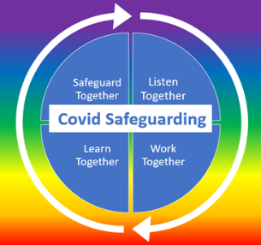
Follow us on @NHSsafeguarding for blogs and updates.
Tweet about it using:
#NHSsafeguarding
#teamCNO

