MODERN SLAVERY /TRAFFICKING
AWARENESS TRAINING
CORNWALL
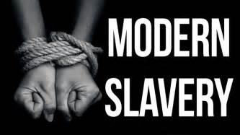
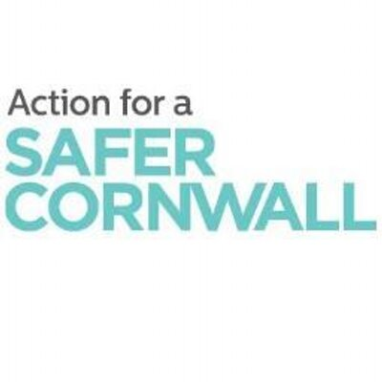

Are you looking for expert training on modern slavery
and human trafficking?
Do you know what it is, how to correctly spot the signs
of exploitation, and what to do about it?
Then look no further - Cornwall Council Community Safety Team in conjunction with Resilience & Emergency Management Team are delivering a Modern Slavery and Human Trafficking training session on 4th December 2019 in the Council Chamber, Cornwall Council, County Hall, Treyew Road, Truro, TR1 3AY. (8.45 am for 9:10 am prompt start).
This bespoke training is for you if you are a front line worker or professional and may come into contact with slavery in the course of your work. You will develop greater knowledge of the law around modern slavery and human trafficking as well as what it looks like in real life.

You will learn how to spot the signs of exploitation, and what you can do if you come into contact with a potential victim. And you will explore the issues facing individuals who have been trafficked and enslaved and find out what support is available.

A number of case studies from Cornwall will show the hidden reality of slavery in the county, how action was taken to support the victims and what legislative tools are available to deal with the perpetrators.

This session will also cover the National Referral Mechanism (NRM) and the Modern Slavery Duty to report.
Duty to notify
Since 1st November 2015, specified public authorities are required to notify the Home Office about any potential victims of modern slavery they encounter in England and Wales. Completing this NRM form is sufficient to satisfy this duty, and this awareness session will guide you through this process.

To register your place at this free training please email Claire.penellum@cornwall.gov.uk
Please note that parking is limited and you are advised to use the park and ride parks at Langarth & Tregurra. (Please allow an additional 30 minutes on your journey).
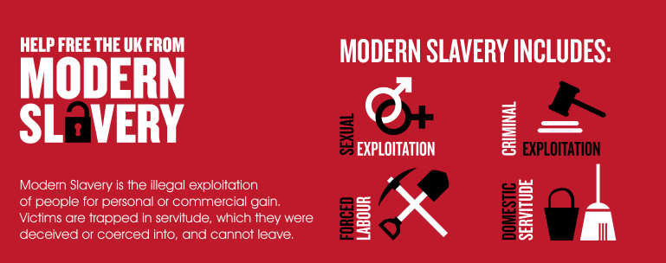
Programme
Modern Slavery /Human Trafficking Awareness Training Programme
0845-0910 – Arrivals and refreshments
0910-0955 – Removing the blindfold to Modern Slavery & Human Trafficking
0955-1040 – Case Studies from Cornwall including Operation Costume
1040-1055 – Comfort break
1055-1140 – National Referral Model
1140-1200 – Peninsula Response Plan and Victim Reception Centre arrangements.

