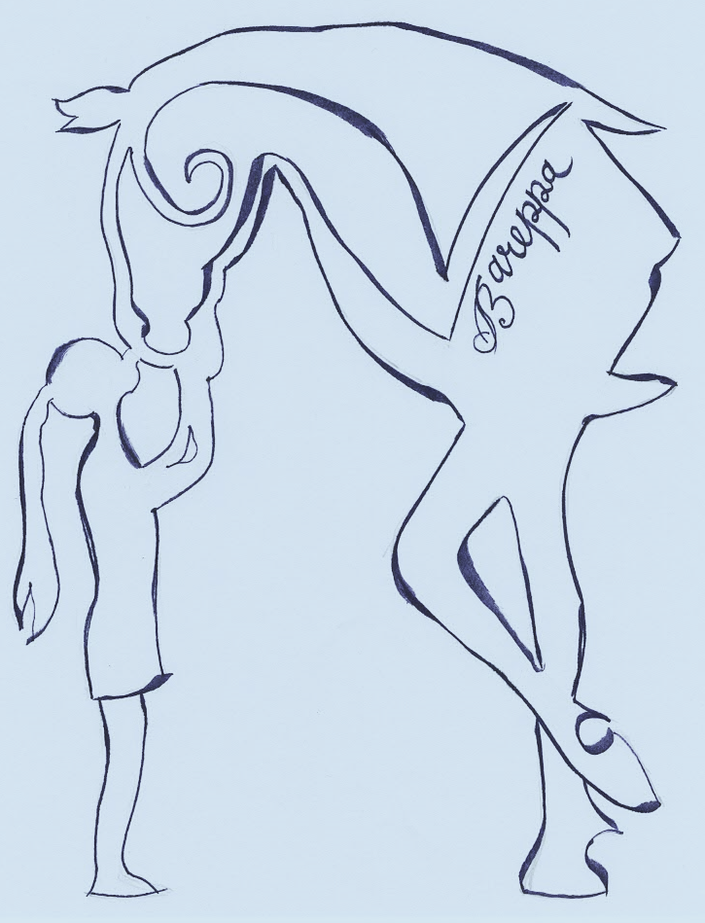
Bareppa
Wellbeing through animal and garden experiences.
St Winnow, Lostwithiel
PL22 0LG

Bareppa is a small holding of 5 acres. The property enables us to enjoy the animals and to have a productive, wildlife friendly and beautiful place to live and work. We have a small menagerie of animals to care for. All the animals here are children (and adult) friendly, each of them having a purpose; to produce food (eggs), for physical activity (riding) or as pets for our pleasure and wellbeing.
We are committed to providing a nurturing and fulfilling experience for children and adults of every ability. We can provide Equine or animal therapy, forest school and horticulture.
We are able to take individuals or groups of up to four clients. Sessions can be tailored to the needs and time scales of each client.
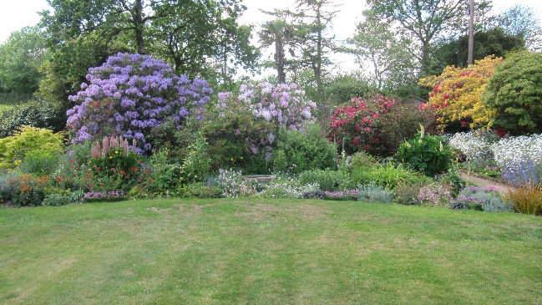
Profile.
Cheryl Turner. I am an experienced forest school teacher, teaching forest school in a primary school for the last ten years. I have owned and ridden horses since I was a small child and having been brought up on a farm, animals and the outdoors are now a part of me. I am also a gardener, at home, and running a small gardening business.
Level 3 forest school leader Outdoor first aid Higher level teaching assistant Animal Assisted Therapist. AHCP.
Joe Flynn. I am retired primary head teacher of 25 years. Throughout my life I have helped out on a farm, learning about animal husbandry and countryside crafts and pursuits. I now do education consultancy and help Cheryl with the gardening business.

We are both enhanced child protection checked and have experience with Autism, Asperger’s syndrome, young carers, the elderly and physical disabilities.

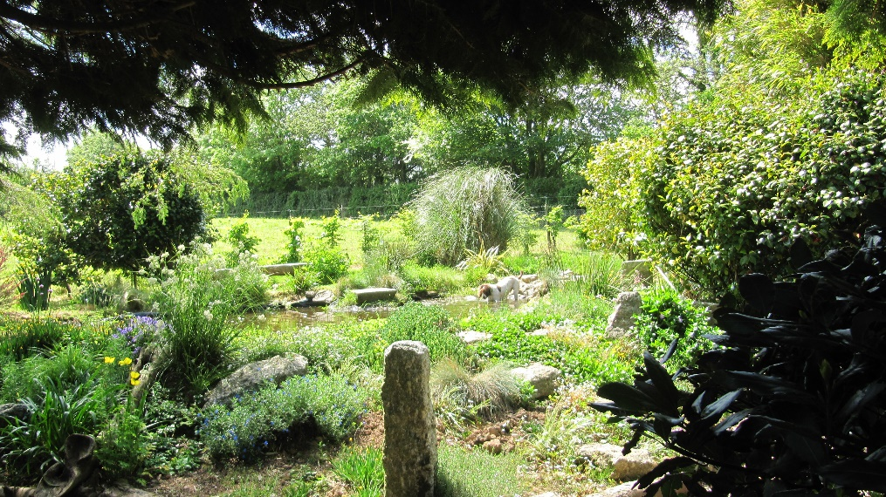

The Activities

Horse and pony management.
- Handling ponies, learning to use basic tack.
- Grooming and interaction.
- Leading and being in control of a pony.
- Learning to care for a pony (feeding, cleaning, maintaining fields etc)
- Progressing to leading a pony around a small obstacle course.
- Taking ponies for woodland walks.
- (NO riding.)

Benefits for clients.
- Learning to take charge of a large animal that has a will and mind of its own, boosting confidence and self-belief.
- To interact with an animal which gives no judgement or comment, allowing the client to discover their strengths for themselves and to build on them.
- To develop empathy with an animal, understanding they have needs and feelings
- Meeting small achievable goals with instant rewards.
- To give and receive affection and respect to and from the animal.
- To find strategies to achieve goals outside of a personal comfort zone.
- To share hopes, fears and inner thoughts to a compassionate, non-judgmental friend.
- To understand that each animal has an individual personality, therefore individual needs.
- To observe behaviour of the ponies/horses as a herd, to understand that each has a role within the herd and to understand the body language and actions naturally used to enforce the herd rules (this can then be applied and understood within personal and social situations for the client.)

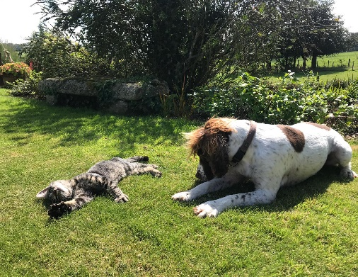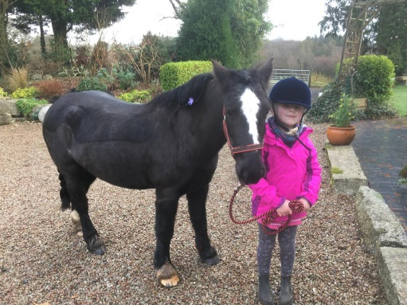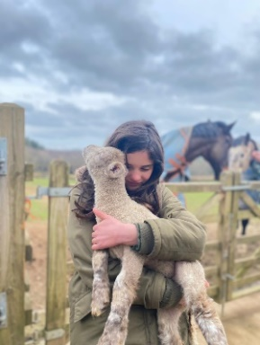

Gardening
- Experience all aspects of growing and maintaining vegetables and flowers.
- Learn how to create a garden for a chosen purpose (to grow a particular fruit or vegetable)
- To work with the seasons and climate.
- To engage in physical work.
Benefits to clients
- To experience achievement through hard work.
- Engaging with nature and the natural world to help ground and calm the body and mind.
- Physical activity helps to reduce stress as well as helping with overall fitness and wellbeing.
- To experience the joy of eating food you have personally grown or to enjoy the tranquillity or recreation of a garden which engages all the senses.

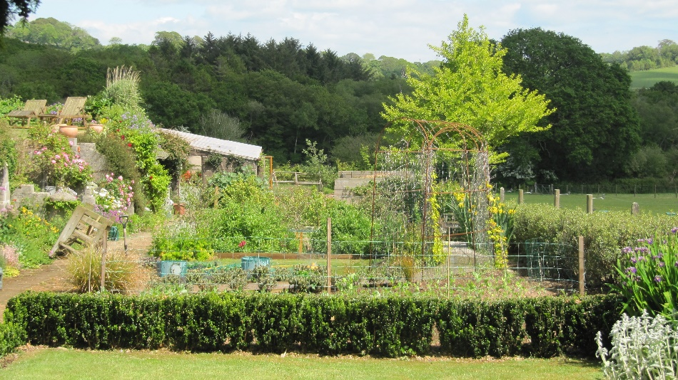

Forest School
- Playing within the natural world
- Engaging with nature
- Learning and observing the natural life around us.
- Climbing trees
- Building dens
- Searching for bugs
- Lighting fires and wild cooking
- Taking risks in a controlled environment
- Survival skills
- Woodwork and whittling
- Animal husbandry (dogs, chickens, wildlife)

Benefits to the client
- Relaxed but safe environment to explore and discover for themselves.
- To learn through trial and error.
- To take risks and learn how to assess a risk.
- To expand personal skills of choice.
- Experience new challenges at their own pace.
- To take personal challenges outside of their own comfort zone.
- Physical activity to burn energy and stress.
- Outdoor activities to increase self-esteem and self-worth.
- To recognise personal achievement and to feel proud.

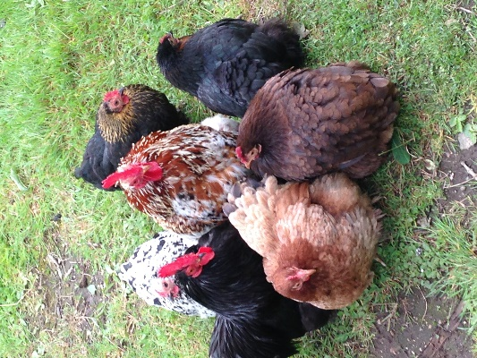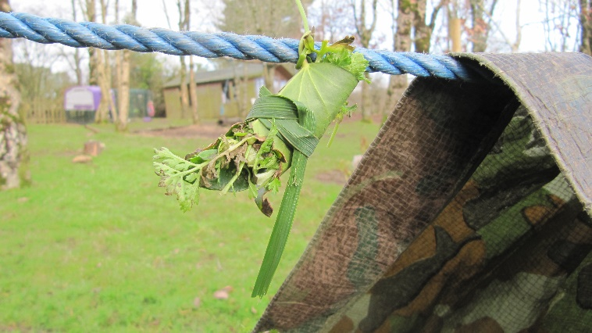

Garden relaxation.
We invite you to the peace and tranquillity of a beautiful setting where families or friendship groups can walk around the garden, have coffee, picnic, or just sit in the quiet of the countryside.

Example of sessions.

Half day 2-3 hr animal experience / forest school / gardening activities.
Time allocated for breaks/snacks etc.
(Clients must be accompanied)
Introduction to ponies and animals with safety talk. Grooming and basic handling of ponies.
Feeding fish and handling chickens, interacting with the animals.
Choice of garden and forest activities as seasonal and available.

Individual sessions @ £35 per hour.
Group sessions negotiable depending on numbers and duration (e.g. Up to 4 clients £120 per session up to 2 hrs).
(All sessions can be tailor- made for the needs of the client/clients.)
Bareppa
St. Winnow, Lostwithiel
PL22 0LG

joeflynny@hotmail.com
cheryl 07877 539172
Joe 07796 334263

