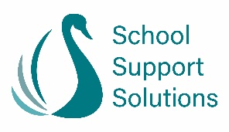

Successful School Improvement
This course is aimed at headteachers new to the role as well as deputy and assistant heads.
Date: Monday 6th June 2022
Venue: B1, Beacon Place, Victoria Offices, Roche, PL26 8LG
Trainers: Faye Heming & John Jones, School Support Solutions
Cost: £150(+VAT) per delegate

Session 1 The school improvement process
We shall begin this course by focusing upon the cycle of school
improvement at a whole school level. We will consider how the school culture can impact upon organisational change, and how to overcome barriers. Freely available tools to support school improvement will be shared.

Session 2 Gathering the evidence
When gathering evidence, we need to view school improvement at a granular level. Using an objective from your current school improvement plan, you will be guided through a process of evidence gathering, where practical strategies will be shared, including a work scrutiny using curriculum plans and pupils’ books from your school (history or geography).

Session 3 Pulling it all together
Once we have gathered our evidence, we need to record this information concisely. This session will focus upon the key components of the school self-evaluation form (SEF).

Session 4 Reflection time and next steps
To end the day, time will be set aside for you to reflect upon the training
and note your next steps. There will also be opportunities to ask questions.

To bring:

- A copy of your current school self-evaluation form (if you have one)
- Your school improvement/development plan.
- Long term plans and progression documents for history/geography, including a medium-term plan (history or geography) for the autumn term for one year group and 4 pupils’ books from that same year group (for a guided work scrutiny)
- A laptop/device to work on during the day.

