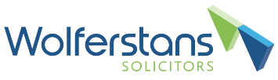
Changes to the SSP Scheme
Background
The rules around Statutory Sick Pay (“SSP”) were temporarily amended during the COVID-19 pandemic, however the expiry date for the amendments is fast approaching. This means that unless the amended regulations are extended, the SSP Rebate Scheme will close on 17 March 2022.
Changes made
The temporary amended regulations allowed employers to reclaim SSP that had been paid for any absences related to Covid or self-isolation, whilst also suspending the waiting period.
From 17 March 2022, the UK will return to the normal regulations surrounding SSP.
This means that employers will no longer be able to claim back SSP relating to COVID-19 absences. They will however have until 24 March to submit any new claims or make any required amendments to claims already lodged.
What do employers need to do?
The main thing is to inform employees that the rules will be reverting and therefore the waiting period will be re-implemented, meaning employees will only be paid from their fourth qualifying day, not the first.
Employers should also ensure that they submit any rebate claims within the timeframe and update any sickness policies that they have in place.

If you would like further advice on the SSP scheme or would like us to review your sickness absences policies, please get in touch with a member of the team on 01752 663295.

