

**The Hugs Foundation, Higher Whitley Farm, Helland Road, Bodmin, PL31 2NT**

**www.hugsfoundation.org.uk**

To book your place please ring **07948404986** or email [**hazel@hugsfoundation.org.uk**](mailto:hazel@hugsfoundation.org.uk)

Quote code **Farm04** for a prize on the day

**February Half Term Holidays Activities**

**Farm Fun Day**

Thursday 20th February 2020

10.00am – 14.00pm £30 per person

**∙ Meet the animals ∙ Woodland based activities ∙ Den building ∙ Tractor fun ∙ Outdoor games ∙ Toasting marshmallows ∙ And much more!**

Booking essential as places are limited and any cancellations made with less than 48 hours’ notice will require full payment, sadly we will not be able to refill your place.

Suitable outdoor footwear and appropriate warm waterproof clothes are essential.

Please remember to bring a packed lunch, snacks and a drink.

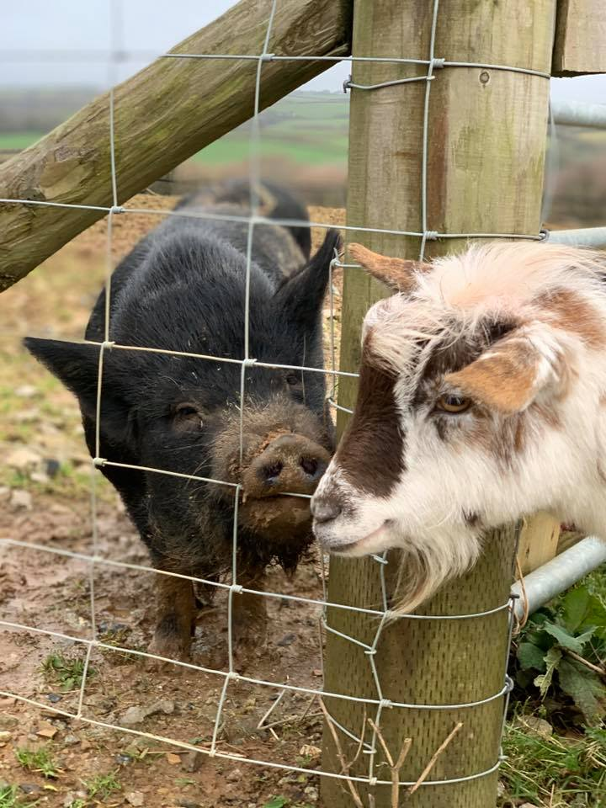



[](https://www.google.co.uk/imgres?imgurl=https%3A%2F%2Fhugsfoundation.org.uk%2Fwp-content%2Fuploads%2F2018%2F03%2FThe-Hugs-Foundation-RGB-01.png&imgrefurl=https%3A%2F%2Fhugsfoundation.org.uk%2F&docid=prvl53T9JWcTxM&tbnid=GkLnQAWNx2k-5M%3A&vet=10ahUKEwiRqIrYnOfmAhVinVwKHTSJCfUQMwhDKAAwAA..i&w=597&h=596&bih=967&biw=1920&q=the%20hugs%20foundation&ved=0ahUKEwiRqIrYnOfmAhVinVwKHTSJCfUQMwhDKAAwAA&iact=mrc&uact=8)